ATM WITHDRAWAL SYSTEM-USECASE DIAGRAM
Exp no:
Date:

AIM:
To study and design a Use Case Diagram for an ATM Withdrawal System in order to understand the interaction between the user, ATM machine, and bank server and to model the cash withdrawal process using UML.

REQUIREMENTS:
Hardware Requirements
- Computer system
- ATM machine (conceptual)
- Network connection
Software Requirements
- UML Diagram tool (StarUML / Draw.io / MS Word)
- Operating System

SYSTEM DESCRIPTION:
The ATM Withdrawal System is an automated banking service that enables customers to withdraw money at any time without going to a bank branch. The system works based on interaction between three main components: User, ATM Machine, and Bank System.
The user inserts the ATM card and enters the Personal Identification Number (PIN). The ATM machine collects this information and sends it to the bank server. The bank server verifies the card details and checks the account balance. If sufficient balance is available, the bank approves the transaction. The ATM then dispenses cash and prints a receipt.

ACTORS:
1. User
The user is the customer who uses the ATM to withdraw money. The user interacts directly with the ATM by inserting the card, entering the PIN, selecting the withdrawal option, and collecting cash and receipt.
2. ATM Machine
The ATM machine is an automated system that provides an interface for the user. It reads the card, accepts the PIN, displays menu options, communicates with the bank server, and dispenses cash.
3. Bank
The bank is the backend system that stores customer account details. It performs authentication, balance verification, and transaction approval or rejection.

USE CASES
- Insert Card
- Enter PIN
- Authenticate User
- Display Menu
- Select Withdrawal
- Enter Amount
- Check Balance
- Withdraw Amount
- Dispense Cash and Receipt
These use cases represent the sequence of operations performed during an ATM withdrawal transaction.

SYSTEM BOUNDARY:
The system boundary is represented around the ATM machine. All the use cases are included within the boundary. The actors such as User and Bank are located outside the boundary. This shows that the ATM system acts as an interface between the user and the bank.

RELATIONSHIPS:
Association:
Association shows the interaction between actors and use cases.
Example: User is associated with Insert Card and Enter PIN.
Communication:
The ATM machine communicates with the bank server for authentication and balance checking.

WORKING PRINCIPLE:
The ATM Withdrawal System works on a client-server model. The ATM sends user requests to the bank server and waits for confirmation before proceeding. This ensures data consistency and security. The system performs real-time processing of transactions.

ADVANTAGES:
- Provides 24/7 banking service
- Reduces crowd in bank branches
- Faster transactions
- User-friendly system
- Secure authentication process

APPLICATIONS:
- Used in banks
- Used in shopping malls
- Used in railway stations
- Used in public places
USECASE DIAGRAM
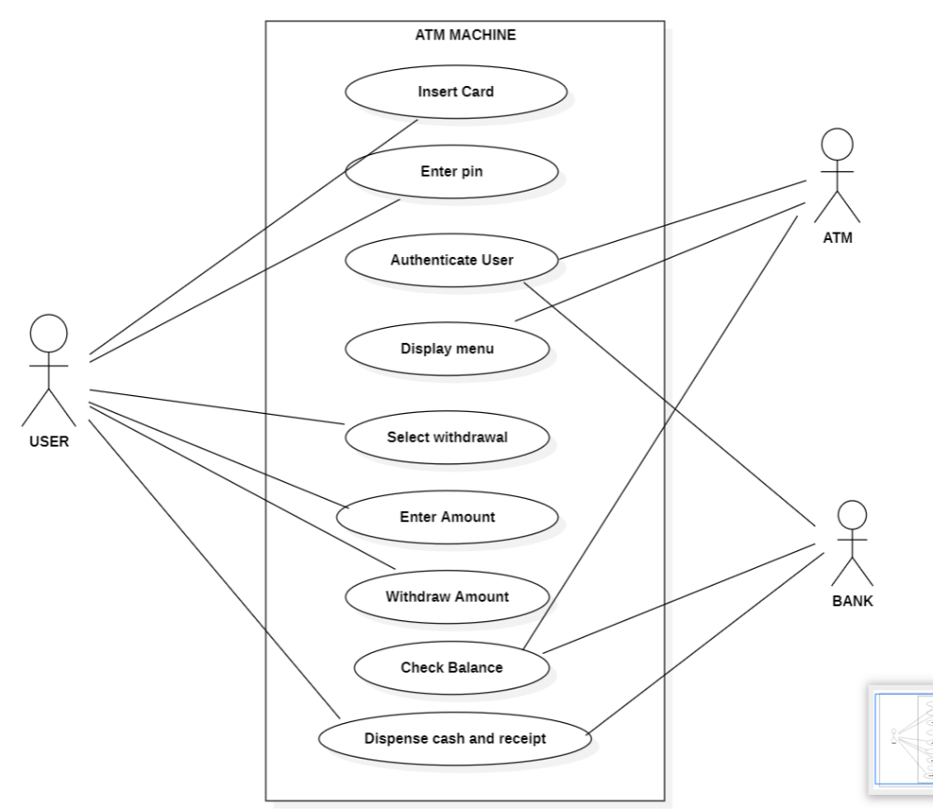

CONCLUSION:
The ATM Withdrawal System Use Case Diagram clearly explains the interaction between the user, ATM machine, and bank system. It shows the sequence of operations such as inserting the card, entering the PIN, selecting withdrawal, and dispensing cash. Thus, the use case diagram helps in understanding the working of the ATM system in a simple and structured manner and provides a clear model of real-time banking operations.

